**Activity Space (Critical Reflection)**

**Activity 1:**

1. What are critical reflections?

* *How do you critically reflect on your experiences?*

1. What are some experiences related to communications that you can reflect on

* *Consider the topics and concepts covered in this module.*

|  |  |
| --- | --- |
| Room 1 (Aileen, Wraine) | Room 2 (Wei Li, Tai, Jun Lim) |
| 1. A critical reflection is a reflection that may not be common for everyone but some thoughts that you as an individual noticed that add value to whatever experience you had before. How you critically reflect differs from one person to another, but the recollection of knowledge gained by a particular moment from interactions with others or a lecture where new kinds of thought. That links everything together 2. When giving a presentation, explanations of a point should be persuasive. Also, non-verbal communication is beneficial to the presentation. | Critical reflections are an in-depth analysis of our thoughts, actions and decisions taken in the past and coming out with a conclusion of what could be done to improve/ prevent future similar situations from occurring/ what is wrong / what is right about it.  -------------------------  Some experiences that we can reflect on include **conflict management**, managing expectations that other people have of us, techniques to articulate the ideas (that we want the other party to hear) in a clear and unambiguous manner, working together towards a common goal and discussing ideas together. |
| Room 3 (Braden, Daryl) | Room 4 edward & isaac |
| 1. Being objective, having a set of rubrics/checklists help us to evaluate our performance 2. In OP1 and OP2 – needs analysis, Communication skills (hand gestures, tone), importance of being persuasive rather than engaging, asking constructive questions. In general – giving feedback diplomatically, how to manage conflicts | 1. Reflect on our experience with a neutral perspective: analyse what happened, why we did what we did -> what was the outcome -> could the outcome be better/worse We should also go more in-depth for each step – for example, 2. what we felt in each step, what were the alternatives, what could be done better, what we have learnt 3. communicating within a team – e.g. conflict management, team meeting Communicating to a specific audience – e.g. your manager, customers |
| Room 5 (Musfirah & Anvitha) | Room 6 (Haziq and Shyun Yin) |
| 1. Instead of merely recounting your experiences, describe and analyse about what you’ve learnt, how you grew and your thought process in detail. Relate to the course topics and also think about what could've been done better. 2. How to work in a team and what to expect when you work in a team (conflict-resolution diagram?). How to persuade your audiences during a presentation using the 3 model framework – ethos, pathos and logos. When creating you presentation contents, take note of the CAP (content, audience and purpose). Importance of non-verbal cues in presentation. How to write a user guide and how to cater to the user needs by identifying CAP. Apart from that, we learnt useful things from the presentation given by our friends. How to critically give feedback, or ask good and relevant questions to the presenter as an audience. Learn from feedbacks given by our friends and tutor. How to conduct a group meeting, and some useful methods to break the ice. | 1. Firstly recall what you did, find out what went well and what went wrong, analyse and find out the reasons for what went wrong so that you can avoid or make it better in the future. 2. Conflict management during 2113 when there were discrepancies. Writing the UG where we had to clearly communicate our ideas so that non-technical users are able to understand it at a glance. Professional competence at the workplace which includes how we communicate with others. Communication with a specific audience especially in OP2 where the audience was quite specific and we had to change the way in which we present the same content. |
| Room 7 (Alan & Emily) | Room 8 (Sharif & Yu Zhong) |
| Q1. Look through our past components that we’ve done and evaluate our performances (i.e. what we have done well, what we could have improve on). In addition, we can also assess how we’ve improved throughout the course of the semester in this module. Give concrete examples of what happen and be descriptive about it.  Q2. OP1, OP2 (our persuasion skills (ethos, logos, pathos), our ability to identify context audience, and purpose, and handling Q&A segments), group meetings (how we communicate our ideas with our teammates, how we resolve conflicts), and consultation/feedback sessions. Documentation skills (being able to write documents that are targeted at our intended audience). | 1. Analyse what you have gained from your experience. Figure out what have gone well and what could have been done better. Looking at the perspectives you had at the start and how they have changed over the course of your project/work. 2. Reflect on the group meetings that were held, how communication is important when it comes to teamwork. How our group has made use of the concepts learnt in class to curate our OP1 and OP2 presentations. How things could have been made better if there were issues along the way. How to craft UG and DG keeping the audience in mind. |

**Activity 2:**

What are some key concepts/ principles that you have gleaned from this module?

**Activity 3:**

Evaluate your **recess week reflections**.

Go to Luminus – CS2101 – [Forum](https://luminus.nus.edu.sg/modules/f77d7143-78cf-47e5-9d88-3d869b9943d1/forum).

* Did you consider the (1) What (2) So What (3) Now What?

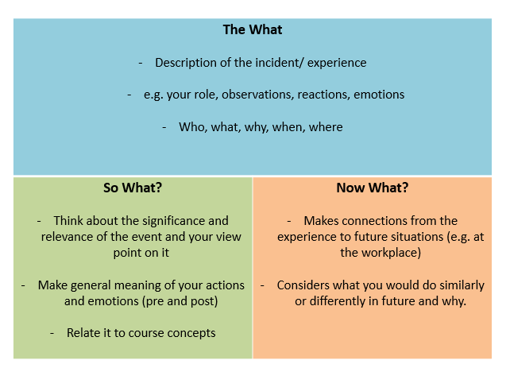

**Activity 4:**

Revise your recess week reflections.

Share your critical reflections with your partner verbally.

**Think about it**

* *How would you structure your critical reflections in writing?*
* *How would you signpost?*
* *What style would you use in your critical reflection?*

**Your CA5 Critical Reflection Task**

|  |
| --- |
| *Write a critical reflection based on your learning journey in CS2101 and CS2103T/CS2113T.*  *Describe one or two experiences that occurred this semester that led to an insightful realisation and subsequent change in the way you communicate or perceive communication.*  *Consider how this is significant for you and how you would do better in the future.* |

Deadline: Week 13 Sunday at 2359

Where: LumiNUS – CS2101 – Files – Submission Folder – Your group folder – CA5 Critical Reflections

Document Name: Full Name_ Critical Reflection *(e.g. Lam Wanli Aileen_ Critical Reflection)*

Please refer to the CA5 Critical Reflection Info Pack for more information.

--------------------------------------------------------------------------------------------------------------------------

|  |
| --- |
| Survey Link:  <https://nus.syd1.qualtrics.com/jfe/form/SV_cMcQulOEEfxNZmS> |

**If you are interested in looking for a job in May, CELC is looking for student helpers. You can read more on this job posting here:**

<https://inetapps.nus.edu.sg/nsws/app/staff/browse-jobs/view-listing/J2022040131>